Hackathon Submission Report

Executive Summary
The Open Software Testing Practice Platform, or BetaHub, is an open-access freelance QA testing marketplace that connects businesses with independent software testers for structured beta testing, bug reporting, usability review, mobile-flow testing, and pre-launch product validation.
The project is built around a practical two-sided market problem.
On one side, startups, SMEs, agencies, and digital businesses often need affordable testing before launching or updating websites, applications, booking systems, e-commerce flows, dashboards, customer portals, or early-stage digital products. However, hiring full-time QA staff can be too expensive for short-term testing needs, while managing individual freelancers can be inconsistent and operationally inefficient.
On the other side, many individuals have the ability or motivation to provide testing services but lack access to real paid projects, client history, marketplace reputation, or a visible portfolio. This includes junior testers, self-taught technical workers, students, career-switchers, and freelancers from non-traditional backgrounds.
BetaHub solves this gap by allowing companies to purchase structured testing campaigns according to their budget, product stage, and risk level. A small startup can choose a low-cost campaign supported by junior testers and platform validation. A growing company can choose a mixed tester pool. A larger launch can use vetted testers and stronger review.
BetaHub manages the operational layer around the transaction: campaign scope, tester matching, bug report templates, evidence requirements, moderation, validation, payout logic, quality control, and dispute handling. The platform retains a service fee from each campaign to cover infrastructure, report validation, moderation, payment processing, abuse prevention, and maintenance.
The UAE is a relevant validation market because its non-oil economy, trade, tourism, finance, logistics, e-commerce, digital services, and AI-driven business transformation are expanding rapidly. As more companies operate through digital channels, they need faster, more affordable ways to identify software quality issues before those issues affect customers.
BetaHub is therefore positioned as freelance QA service infrastructure: it converts independent testing capacity into structured business value.

Impact and Value to the Community

The Problem: Companies Need Flexible Testing, Testers Need Access to Real Work
Software testing is a practical service that many companies need, but not every company can justify a permanent QA hire.
A startup may need testing before launching an MVP.
An SME may need a website checked before a campaign.
An e-commerce business may need checkout-flow validation.
A service company may need booking forms, mobile layouts, or customer journeys reviewed.
A digital agency may need external testers before delivering work to a client.
For these businesses, the problem is not only technical. It is economic and operational. They need flexible, affordable, structured testing capacity without the fixed cost of hiring.
The current alternatives are limited:
- hiring a full-time QA employee creates a fixed monthly cost;
- hiring a traditional freelancer requires manual selection, briefing, validation, and payment handling;
- informal feedback from friends or users is usually unstructured;
- professional QA audits may be too expensive for early-stage testing needs;
- automated tools cannot fully replace real-user review across devices, browsers, and user behaviour.
Independent testers face a different access problem. A person may be capable of checking websites, documenting bugs, testing mobile flows, or reviewing usability, but still struggle to access paid work because they lack previous clients, marketplace reviews, or formal employment history.
BetaHub addresses both sides. It gives businesses a structured way to buy testing services and gives independent testers a controlled path into real freelance QA work.
BetaHub is also designed to be a reliable and trusted testing environment for the UAE market. Trust is built through clear campaign scope, structured bug-report templates, evidence requirements, admin validation, tester reputation, and transparent company feedback. This reduces the risk of low-quality submissions and makes the service more dependable for businesses that need external testing support.

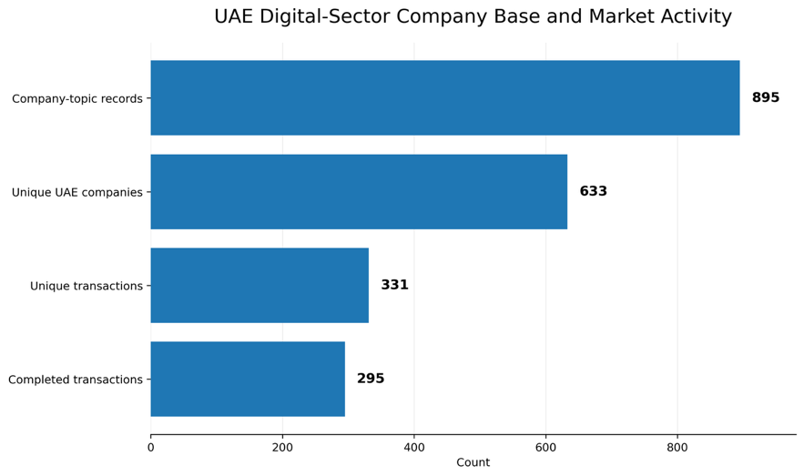

Target Beneficiaries
BetaHub serves two primary groups.

Businesses
The platform is designed for:
- startups with limited QA budgets;
- SMEs needing pre-launch checks;
- e-commerce businesses testing customer journeys;
- SaaS products testing onboarding and dashboards;
- digital agencies needing external validation;
- service businesses with booking, registration, or payment flows;
- early-stage founders who cannot hire full-time QA;
- companies that need multi-device and multi-user feedback.

Independent Testers and Freelancers
The platform is designed for:
- junior QA testers;
- self-taught testers;
- students with basic digital or testing skills;
- freelancers building their first client history;
- career-switchers entering digital work;
- people from non-traditional backgrounds;
- experienced testers seeking additional freelance tasks;
- users who need a lower-barrier entry point into paid QA work.

Evidence of the Current Opportunity Gap
Recent workforce evidence shows that the digital-skills gap is already a business problem, not only a future risk. The World Economic Forum’s 2025 employer survey, based on more than 1,000 major employers across 55 economies, identifies skills gaps as the largest barrier to business transformation. In the same report, employers name AI and big data, networks and cybersecurity, and technological literacy among the fastest-growing skill areas. Quality control, programming, and technological literacy are also identified as skills that increasingly separate growing roles from declining ones.
This evidence matters for BetaHub because software testing sits directly inside this practical-skills gap. QA work requires more than theory: testers must understand user journeys, reproduce defects, document expected and actual results, classify severity, communicate clearly with product teams, and produce reports that businesses can act on. These are employability skills, not only classroom topics.
The UAE market strengthens this opportunity. In 2025, the UAE economy remains strongly driven by non-oil business activity. Non-oil sectors account for around 77% of GDP, and non-oil activity grew by 5.3% year-on-year in Q1 2025, supported by sectors such as manufacturing, finance, construction, and real estate. This means more companies are operating through websites, apps, booking flows, payment journeys, dashboards, customer portals, and digital service platforms. As digital business activity expands, the need for affordable functional testing, usability testing, mobile review, and customer-journey testing becomes more immediate.
Current research also shows that software testing education still has a practical-execution gap. A 2025 study on software-testing education found that students often struggle with foundational testing concepts such as decision coverage and exception handling, and that many revisions to test suites are superficial rather than improving real coverage. This supports the need for guided, practice-based testing environments where learners can build skill through repeated, structured tasks.
There is also UAE-specific evidence that software testing can be an underused career path. A study of 132 senior software-related students across three UAE universities found that software testing is recognized as vital to software quality, but the tester role may be misunderstood or stigmatized. The study also found that UAE software-related students showed a stronger negative attitude toward software testing than students in comparable studies from other countries.
For BetaHub, this creates a clear market logic. The problem is not only that learners need training. The problem is that many learners need a practical route into real QA work, while companies need affordable testing capacity for short-term digital projects.
Platform addresses both sides of the gap. Independent testers can begin with lower-risk testing tasks, build proof of work through accepted reports, and develop practical QA experience. Companies receive structured feedback on real business tasks without committing to full-time QA hiring. This turns the skills gap into a service pathway: learners gain demonstrable experience, and companies receive usable testing output.
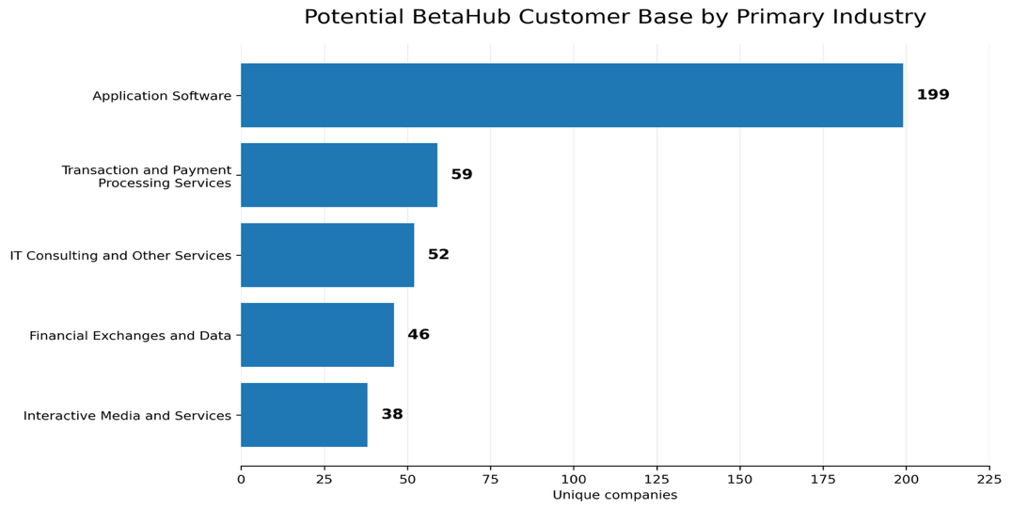

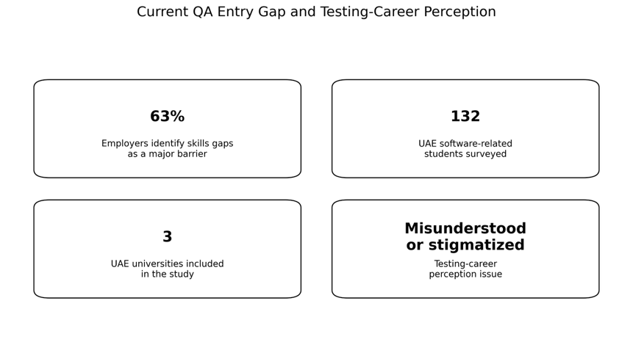

Tiered Marketplace Model
BetaHub uses a tiered service model so that businesses with different budgets can access testing at an appropriate level.
A small startup does not always need a senior QA consultant. It may need basic functional testing, mobile review, broken-link checking, form validation, content review, and usability feedback. This can be handled by junior testers using structured templates and platform validation.
A growing business may need broader device coverage, more testers, severity classification, and a stronger QA summary. This requires a mixed pool of junior and intermediate testers.
A larger or higher-risk product may need more experienced testers, stricter validation, deeper reporting, and additional admin review.
This model creates access on both sides:
- small companies can afford testing;
- junior testers can enter the freelance market through lower-risk campaigns;
- experienced testers can access higher-value campaigns;
- companies can scale testing depth as their budget and product risk increase.
The business does not pay for the tester’s education. It pays for a testing service at the appropriate campaign level. The platform manages quality control so that junior testers can contribute safely on suitable tasks.

Company Risk and Early Testing Need
Companies face financial and operational risk when software defects are discovered late. A broken checkout flow, unclear registration process, mobile layout issue, accessibility problem, form validation error, broken link, or weak user journey can lead to lost revenue, reputational damage, higher customer support costs, and delayed launches.
This risk is especially relevant in the UAE because the economy is increasingly digital, service-based, and customer-facing. Businesses in e-commerce, tourism, real estate, logistics, finance, education, and government services now rely on websites, applications, booking flows, payment journeys, dashboards, and customer portals. When these systems fail, the issue is not only technical. It can directly affect customer trust and business performance.
UAE-specific cybersecurity evidence shows that digital risk is already active, not theoretical. In 2026, Reuters reported that the UAE had foiled organized cyberattacks targeting digital infrastructure and critical sectors, including attempts involving ransomware and phishing campaigns. The report, citing the state news agency, also noted that artificial intelligence had been used to develop offensive cyber tools.
Regional reporting also shows the scale of exposure. During a period of regional tension, cyberattack attempts against the UAE reportedly rose from around 200,000 per day to nearly 600,000 per day, with financial services, government platforms, ports, and utilities among the affected target areas.
Consumer-facing digital risk is also visible in the UAE. Abu Dhabi Police reported the recovery of AED 140 million from cyber-fraud cases over two years, covering more than 15,000 cases. This evidence does not measure software defects directly, but it shows that digital trust, online transactions, and user protection are already major practical issues in the UAE market.
Digital Platform does not replace penetration testing, cybersecurity audits, legal compliance review, or internal QA ownership. Instead, it provides an earlier and more accessible testing layer focused on:
• functional issues;
• usability problems;
• mobile responsiveness;
• form and flow errors;
• broken links;
• checkout and booking-flow friction;
• unclear user journeys;
• basic risk signals before launch.
This makes BetaHub useful for UAE startups, SMEs, agencies, and digital service providers that need early validation before customers experience visible product failures. The platform helps companies identify practical software-quality issues earlier and more affordably, while also creating real QA tasks for independent testers.

Community Benefit
BetaHub creates community value by converting independent testing capacity into structured freelance service delivery.
For businesses, the platform provides:
- lower-cost testing options;
- flexible campaign-based QA support;
- structured bug reports;
- multiple testers instead of one reviewer;
- wider device and user coverage;
- reduced launch risk;
- no long-term hiring commitment.
For independent testers, the platform provides:
- access to real testing tasks;
- potential paid work;
- portfolio evidence;
- client-style reporting experience;
- a path into freelance QA regardless of formal background;
- progression from junior campaigns to higher-value work.
For the wider ecosystem, BetaHub creates a practical marketplace that supports digital quality, freelance access, and workforce participation.
The impact is substantial because it solves a real two-sided market problem: companies need affordable testing services, and independent testers need access to real work.

Relevance to the Challenge
BetaHub directly addresses the challenge by creating a practical, community-oriented solution for workforce access and digital business support.
The project is relevant because it targets a specific high-value problem: companies need affordable QA testing, while many potential testers lack access to paid service opportunities.
Platform is not an online course and not a traditional education platform. It is an open-access freelance QA marketplace with structured service validation.
The project supports the challenge in four ways.
First, it improves access to digital work. Independent testers can join the platform, complete onboarding, and begin with suitable testing tasks according to their capability level.
Second, it supports workforce development through real service delivery. Testers build practical evidence by submitting structured reports for real business campaigns.
Third, it supports startups and SMEs. These businesses can purchase testing services without taking on the fixed cost of a full-time QA employee.
Fourth, it creates a sustainable model. Companies pay for testing services, testers are rewarded for validated work, and the platform retains a service fee to maintain operations.
This makes BetaHub directly aligned with the challenge: it addresses a real market gap, benefits a defined community, and creates a practical path to sustainability.

Feasibility of Implementation
BetaHub is feasible because it can be implemented with standard web technologies, a clear role structure, and a staged development plan.
For the hackathon selection round, the project is presented as a clickable MVP. The prototype demonstrates the platform hierarchy, core user journeys, company campaign creation, tester task flow, bug report structure, task moderation, payout logic, and cost-saving model.
The planned implementation can be built using:
- React or Next.js for the frontend;
- Node.js or another lightweight backend framework;
- PostgreSQL for users, campaigns, reports, payouts, and reputation data;
- cloud hosting through a low-cost VPS or scalable cloud provider;
- file storage for screenshots and attachments;
- role-based access control;
- admin moderation tools;
- structured report validation;
- payment processing in later stages.

User Roles

Businesses
Businesses can:
- create a company account;
- choose a campaign tier;
- submit a website, app, or product link;
- set a campaign budget;
- review submitted reports;
- approve validated reports;
- download a QA summary.

Independent Testers
Testers can:
- create an account;
- complete onboarding;
- select available campaigns;
- submit structured bug reports;
- attach evidence;
- track accepted and rejected reports;
- build a portfolio;
- receive rewards for validated work;
- progress to higher-value campaigns
Implementation Stages

Stage 1 — MVP
This stage includes:
- clickable prototype;
- public landing page;
- business dashboard;
- tester dashboard;
- campaign tier selection;
- bug report form;
- task moderation flow;
- cost-saving calculator;
- tester reward calculator;
- demo walkthrough.

Stage 2 — Core Functional Build
This stage includes:
- authentication;
- user roles;
- company campaign creation;
- tester task view;
- bug report submission;
- report review;
- admin approval flow;
- basic reputation tracking.

Stage 3 — Marketplace and Payout Logic
This stage includes:
- campaign budgets;
- tester reward pool;
- report validation;
- company QA summary;
- platform service fee;
- tester reputation;
- dispute handling;
- manual or semi-automated payouts.

Stage 4 — Scalable Marketplace
This stage includes:
- public GitHub repository;
- contributor guide;
- report templates;
- quality guidelines;
- tiered tester verification;
- multilingual interface;
- business partnerships;
- institutional or accelerator partnerships.
Key Constraints and Mitigation
The main implementation constraints are:
- low-quality or fake bug reports;
- spam submissions;
- unclear testing scopes;
- company disputes;
- payment abuse;
- data privacy;
- moderation workload;
- infrastructure cost.
These constraints are manageable.
Bug report quality can be improved through structured forms requiring:
- bug title;
- severity;
- steps to reproduce;
- expected result;
- actual result;
- screenshot;
- device;
- browser;
- operating system;
- test environment;
- optional screen recording.
Spam can be reduced through account reputation, report limits, admin moderation, and validation rules.
Company disputes can be managed through clear campaign scope, evidence requirements, and admin review.
Payment risk can be reduced by starting with manual payout approval before introducing automation.
The early MVP does not require complex automated browser infrastructure. The first working version can focus on manual testing workflows, structured reports, campaign matching, validation, and admin moderation. This makes implementation realistic for a small hackathon team.
Readiness of the Solution
For the hackathon selection round, BeatHub is presented as a clickable MVP rather than a fully deployed backend product.
The MVP demonstrates the complete service logic from end to end:
- company selects a testing campaign;
- company submits a product link and testing scope;
- tester sees available campaigns;
- tester submits a structured bug report;
- company validates the report;
- company receives a QA summary;
- tester receives a reward from the campaign pool;
- platform retains a service fee.
The MVP is designed to show product readiness, user flow clarity, business logic, pricing structure, and implementation feasibility.
The solution is not only an idea. The team has defined:
- user roles;
- marketplace structure;
- report template;
- validation flow;
- payout logic;
- business model;
- cost-saving model;
- graph-backed evidence of market relevance;
- repository documentation plan.
This level of readiness is appropriate for the selection stage because it allows judges to evaluate the product concept, workflow, business logic, and feasibility before full engineering resources are committed.
Cost and Savings Model: Hiring vs BetaHub Testing Campaign
BetaHub creates economic value by offering companies a flexible alternative to full-time QA hiring and unmanaged freelance testing.
The company pays for a testing service, not for tester education. The tester gains experience because the service is delivered on a real business task.
The pricing model is tiered so that businesses with different budgets can access an appropriate level of testing.
Option | Example Cost to Company | Suitable For | What the Company Gets | Main Limitation
Full-time QA hire | AED 10,000–14,000 per month | Companies with continuous QA workload | Dedicated internal QA resource with product knowledge | High fixed cost, recruitment time, onboarding, visa/employer overhead, limited user diversity
Traditional freelancer | AED  3,000–5,000 per task | Companies comfortable managing one external contractor | One tester for a defined scope | Quality varies; company manages brief, validation, report structure, and payment
BetaHub  Starter Campaign | AED 1,500 | Startups, MVPs, landing pages, small websites | 5–7 junior or entry-level testers, structured reports, screenshots, device details, admin validation | Best for low-risk products and basic functional/usability testing
BetaHub  Growth Campaign | AED 3,000 | SMEs, e-commerce flows, booking systems, SaaS onboarding | 10–15 mixed-level testers, broader device/browser coverage, validated reports, QA summary | Requires clear campaign scope and moderation
BetaHub Launch Campaign | AED 6,000 | Larger launches, agencies, funded startups | 20+ testers, stronger validation, severity levels, structured export, deeper QA summary | Not a replacement for professional penetration testing or internal QA ownership

The pricing is an illustrative MVP model and should be validated through UAE market testing.
Tier Logic
- Starter Campaign — Low-Budget Business / Junior Tester Access
The Starter Campaign is designed for startups and small businesses with limited budgets. It gives them access to basic testing without hiring a full-time QA employee.
This tier is also the entry point for junior testers. They can work on lower-risk tasks such as:
- broken links;
- layout issues;
- mobile responsiveness;
- form validation;
- unclear user flows;
- basic usability issues;
- spelling or content defects;
- simple checkout or booking-flow checks.
This gives junior testers real experience while still protecting companies through structured report templates and platform validation.
- Growth Campaign — SME / Mixed Tester Pool
The Growth Campaign is designed for companies that need broader coverage and more reliable testing output.
This tier can include a mix of junior and intermediate testers. Junior testers may identify surface-level issues, while stronger testers handle more complex workflows, multi-step flows, and severity classification.
This gives companies better coverage without the cost of hiring a full-time QA resource.
- Launch Campaign — Higher-Risk Product / Vetted Tester Pool
The Launch Campaign is designed for larger releases, funded startups, agencies, or companies preparing a visible public launch.
This tier should use more experienced or vetted testers, stricter report validation, and a more detailed QA summary.
It is not positioned as a replacement for penetration testing, legal compliance review, or internal QA ownership. It is a structured external beta-testing layer.

Example Company Saving
If a company has a short-term testing need before launch, hiring a full-time QA employee may create a fixed monthly cost of approximately AED 12,000.
A comparable BetaHub Growth Campaign could cost AED 3,000.
Estimated saving:
AED 12,000 - AED 3,000 = AED 9,000
Estimated saving percentage:
AED 9,000 / AED 12,000 = 75%
This means the company can reduce short-term testing cost by approximately 75% compared with maintaining a full-time QA resource for a temporary testing need.
Compared with a traditional freelancer costing AED 4,000, an OSTPP Growth Campaign at AED 3,000 could save approximately AED 1,000, or 25%, while giving the company access to multiple testers instead of one individual reviewer.
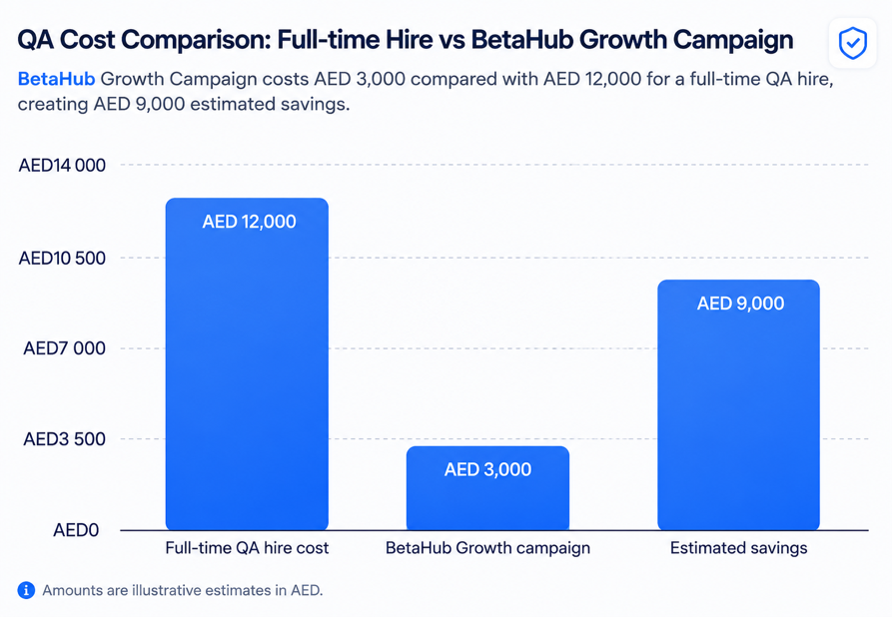

“A BetaHub Growth Campaign could reduce short-term testing cost by approximately 75% compared with a one-month full-time QA cost assumption.”

Platform Revenue Split
For a Growth Campaign priced at AED 3,000:
Allocation | Amount | Share
Tester rewards pool | AED 2,850 | 95%
OSTPP platform service fee | AED 150 | 5%
Total campaign price | AED 3,000 | 100%
The platform service fee covers:
- infrastructure;
- report moderation;
- validation of submissions;
- payment processing;
- dispute handling;
- abuse prevention;
- campaign support;
- platform maintenance.
This model keeps access open for testers while creating a realistic path to platform sustainability.

Tester-Side Economic Benefit
BetaHub gives testers access to real freelance tasks without requiring a traditional employment background.
The platform does not guarantee income. However, it creates a structured route for testers to build paid work history.
Illustrative tester reward model:
Tester Activity | Example Reward
Minor validated bug report | AED 30–50
Medium severity validated issue | AED 60–100
High-value usability or functional issue | AED 100–200
Complete accepted testing task | AED 150–300

Example earning scenarios:
Tester Level | Accepted Reports / Tasks | Average Reward | Estimated Monthly Reward
Entry-level tester | 5 accepted reports | AED 60 | AED 300
Active tester | 10 accepted reports | AED 80 | AED 800
Strong contributor | 15 accepted reports | AED 100 | AED 1,500
The value for testers is not only income. It is also proof of service delivery: accepted reports, rating history, campaign participation, and portfolio evidence.

Scalability After the Hackathon
BetaHub is designed to scale beyond the hackathon because the marketplace model can grow across companies, testers, campaign types, and regions.
The platform can scale technically because the system is role-based and modular. Company accounts, tester profiles, campaigns, reports, admin review, payout records, and reputation scoring can expand independently.
The business side scales through campaign tiers. As more companies use Platform, more testing campaigns become available. As more campaigns become available, testers have more opportunities to build history and progress to higher-value work.
The tester side scales through reputation and validation. Junior testers can begin with low-risk tasks. Reliable testers can progress to higher-value campaigns. Experienced testers can support launch campaigns and deeper review.
The platform can also scale geographically. The UAE can be an initial validation market because of its strong non-oil economy, international workforce, business activity, digital services, and startup ecosystem. After validation, the same model can be replicated in other markets with similar SME and digital transformation needs.
BetaHub can also scale through partnerships with:
- startup accelerators;
- SME support organisations;
- digital agencies;
- coding bootcamps;
- universities;
- freelancer communities;
- business councils;
- technology communities.
The long-term goal is to create a repeatable freelance QA service infrastructure where companies can buy structured testing services and independent testers can access real work.
Falsifiability and Evidence
BetaHub makes specific, testable claims that can be validated during and after the hackathon. The project does not rely only on broad statements about digital transformation or workforce development. It defines measurable assumptions, validation methods, and success thresholds.
Because BetaHub was developed within a 36-hour hackathon window, the project does not claim completed commercial validation with companies at this stage. Instead, the evidence is structured around three layers:
- external market evidence;
- MVP and product-flow evidence;
- post-hackathon validation metrics.

Evidence Base
The evidence for BetaHub focuses on the two sides of the marketplace: business demand and tester access.
On the business side, S&P Capital IQ Pro Market Map exports dated 26-Jun-2026 show a visible base of UAE companies operating in selected digital and technology sectors. The export set identifies 895 company-topic records, 633 unique UAE companies after deduplication, 331 unique transaction records, and 295 completed transaction records. This supports the market relevance of BetaHub because companies in software, fintech, payment processing, IT services, financial data, artificial intelligence, machine learning, and interactive media often depend on websites, applications, dashboards, onboarding flows, payment journeys, booking systems, and customer portals.
This evidence should not be interpreted as confirmed spending on QA testing. It shows potential customer base and market activity, not confirmed willingness to pay. BetaHub therefore uses this evidence as a market-relevance indicator, while willingness to pay will be tested through pilot campaigns after the hackathon.
On the tester side, public workforce evidence shows that skills gaps are already a major barrier for employers, while UAE-specific software-testing research shows that testing can be misunderstood or stigmatized among software-related students, even though it is vital to software quality. This supports the need for a practical route into real QA work through structured tasks, accepted reports, and portfolio evidence.

Testable Claims
BetaHub is built around six measurable assumptions.
First, businesses should find structured short-term QA campaigns useful. This can be tested through pilot campaigns with startups, SMEs, student products, or digital agencies. The target is that at least 60% of participating companies or product owners rate the reports as useful or actionable.
Second, junior testers should be able to produce useful reports when they are given structured templates, examples, and lower-risk testing tasks. This can be tested by tracking accepted and rejected reports in Starter Campaigns. The target is that at least 50% of junior tester reports are accepted after onboarding and initial guidance.
Third, mixed tester pools should provide broader coverage than one individual reviewer. This can be tested by comparing a multi-tester campaign with a single-reviewer baseline on the same product flow. The target is that multi-tester campaigns identify at least 30% more unique valid issues.
Fourth, BetaHub should reduce short-term testing cost compared with full-time QA hiring. This can be tested by comparing campaign prices with full-time QA cost assumptions and company-reported alternatives. The target is at least 50% lower cost for short-term testing needs.
Fifth, independent testers should be able to build portfolio evidence through accepted reports. This can be tested by tracking accepted reports, profile history, ratings, and repeat participation. The target is that at least 70% of active testers have accepted reports visible in their profile after 60 days.
Sixth, the marketplace should be able to support platform sustainability. This can be tested by tracking campaign revenue, tester rewards, platform fee, moderation time, infrastructure cost, and dispute rate. The target is that the platform fee covers core operating cost after the first paid pilot phase, or clearly identifies the campaign volume required for sustainability.

Evidence Plan
During the hackathon, BetaHub can demonstrate the core product logic through a clickable MVP: company campaign creation, tester task view, structured bug report submission, admin validation, company QA summary, tester reward status, sample campaign data, and sample accepted or rejected bug reports.
The hackathon evidence also includes graph-backed market relevance from S&P Capital IQ Pro, current practical-entry evidence for future QA testers, and an illustrative cost-saving model. These materials show that BetaHub is not only an idea, but a testable service model with defined users, workflows, assumptions, and validation metrics.
After the hackathon, the team should run a structured validation phase with 3–5 startups, SMEs, student products, or digital agencies and 10–20 junior testers, students, career-switchers, or self-taught testers. The pilots should track submitted reports, accepted reports, rejected reports, duplicated issues, company usefulness ratings, tester improvement, multi-tester coverage, moderation time, and operational cost.
This makes BetaHub falsifiable. If companies do not find the reports useful, if junior testers cannot produce acceptable output, if multi-tester campaigns do not improve coverage, or if moderation costs are too high, the team will be able to measure the weakness clearly and adjust the model.

